AI-Powered FTIR Analytics Platform
An Intelligent Quality Analytics Platform Powered by
Natural Language Processing and Large Language Models

A Project Report Submitted in Partial Fulfillment of the
Requirements for the Award of the Degree of
Bachelor of Technology
in
Computer Science and Engineering

Submitted By:
Siddharth Kumar Maurya
23/CS/411

Department of Computer Science and Engineering
Delhi Technological University
Academic Year: 2026

Certificate
This is to certify that the project report entitled "Automotive QA Analytics System" submitted by Siddharth Kumar Maurya (Roll No: 23/CS/411) is a bonafide record of the project work carried out under my guidance and supervision in partial fulfillment of the requirements for the award of the degree of Bachelor of Technology in Computer Science and Engineering from Delhi Technological University during the academic year 2025–2026.

Project Guide
[Guide Name]
[Designation]
Head of Department
[HoD Name]
Dept. of CSE

Date: _______________
Place: _______________

Acknowledgement
I would like to express my sincere gratitude to my project guide [Guide Name] for their invaluable guidance, constant encouragement, and constructive feedback throughout the development of this project. Their expertise in the field of Artificial Intelligence and Data Analytics has been instrumental in shaping the direction and quality of this work.
I am grateful to the Head of the Department of Computer Science and Engineering, [HoD Name], for providing the necessary infrastructure and an intellectually stimulating environment. I extend my thanks to all faculty members who imparted foundational knowledge in machine learning, natural language processing, and database systems that formed the backbone of this project.
I also acknowledge the contributions of the open-source community, particularly the developers of Sentence Transformers, Llama.cpp, Streamlit, and SQLite, whose tools made this project possible.
Finally, I thank my family and peers for their unwavering support and motivation throughout this academic endeavor.

Siddharth Kumar Maurya
[Place], July 2026

Abstract
The Automotive QA Analytics System is an intelligent, AI-powered quality analytics platform designed to revolutionize how automotive manufacturers analyze field technical incident reports (FTIR). Traditional quality management relies on manual inspection of spreadsheets and static dashboards, which is error-prone, time-consuming, and fails to uncover latent patterns in large-scale failure data.
This project introduces an NLP-driven analytics pipeline that enables users to interact through a natural language chat interface built with Streamlit, posing questions such as "What are the top failure modes in India for model YNC?" The system automatically classifies intent (SEARCH or ANALYTICS), extracts named entities (trouble codes, product models, countries), generates validated SQL queries using a locally hosted Qwen 2.5 7B language model via Llama.cpp, executes them against a normalized SQLite database, computes KPIs, and renders interactive Plotly visualizations — all in real time.
Key innovations include a semantic search pipeline using Sentence Transformers for embedding-based record retrieval, a two-level (L1 RAM + L2 SQLite) query caching system, heuristic root-cause derivation during ETL, an automated visualization agent that selects optimal chart types, and a retry mechanism with hallucination prevention for LLM-generated SQL. The system serves as a complete business intelligence solution for automotive quality departments.

Table of Contents
Chapter 1: Introduction ........................................ 1
Chapter 2: Literature Survey ........................................ 5
Chapter 3: Requirement Analysis ........................................ 10
Chapter 4: System Design ........................................ 13
Chapter 5: Database Design ........................................ 18
Chapter 6: System Implementation ........................................ 23
Chapter 7: User Interface ........................................ 31
Chapter 8: Results & Performance Evaluation ........................................ 34
Chapter 9: Testing & Validation ........................................ 38
Chapter 10: Challenges & Future Enhancements ........................................ 41
Chapter 11: Conclusion ........................................ 44
References ........................................ 46
Appendix ........................................ 48

List of Figures
Figure 4.1: High-Level System Architecture
Figure 4.2: Four-Layer Architecture Diagram
Figure 4.3: Data Flow Diagram (Level 0)
Figure 4.4: Sequence Diagram — Query Processing
Figure 4.6: Use Case Diagram
Figure 5.1: Entity-Relationship Diagram
Figure 7.1: Login Screen UI
Figure 7.2: Chat Interface UI
Figure 7.3: Analytics Visualization UI

List of Tables
Table 2.1: Comparison of Existing Systems
Table 3.1: Functional Requirements
Table 3.2: Non-Functional Requirements
Table 3.3: Hardware Requirements
Table 3.4: Software Requirements
Table 3.5: Technology Stack
Table 5.1: Records Table Schema
Table 5.2: Users Table Schema
Table 5.3: Chat Sessions Table Schema
Table 5.4: Chat History Table Schema
Table 5.5: Query Cache Table Schema
Table 5.6: Embedding Cache Table Schema
Table 5.7: Materialized View — mv_country_month
Table 5.8: Materialized View — mv_trouble_codes
Table 5.9: Materialized View — mv_dealer_summary
Table 5.10: Materialized View — mv_quality_dist
Table 5.11: Indexing Strategy
Table 8.1: Performance Metrics
Table 8.2: Sample Query Results
Table 9.1: Functional Test Cases
Table 9.2: Performance Test Results

Chapter 1 — Introduction

1.1 Background
The automotive industry generates thousands of Field Technical Incident Reports (FTIRs) annually as part of its quality assurance lifecycle. Each FTIR documents a vehicle failure event, capturing structured data such as product model codes, diagnostic trouble codes (DTCs), customer complaints, technician inspection results, causal parts information, and resolution status. These reports are critical for identifying systemic defects, initiating countermeasures, and ensuring regulatory compliance.
Traditionally, quality engineers analyze FTIR data using Microsoft Excel spreadsheets and manual SQL queries — a process that is labor-intensive, error-prone, and incapable of surfacing latent correlations. As data volumes grow, there is an urgent need for intelligent, AI-driven analytics platforms that allow non-technical stakeholders to query complex datasets using natural language and receive instant, actionable insights.

1.2 Problem Statement
The following challenges define the problem space addressed by this project:
- Manual FTIR analysis is time-consuming and requires SQL expertise that most quality engineers lack.
- Existing dashboards are static and cannot adapt to ad-hoc, exploratory queries.
- No commercially available tool combines semantic search with structured SQL analytics for automotive QA data.
- Large Language Models (LLMs) can generate SQL but suffer from hallucinations, producing syntactically correct but semantically invalid queries.
- There is no unified platform that integrates natural language querying, semantic retrieval, automated visualization, and analytics for automotive FTIR data.

1.3 Motivation
The motivation for developing this system stems from several industry and academic imperatives:
- Democratize data access: Enable non-technical quality engineers to query complex datasets using conversational English.
- Accelerate root-cause analysis: Reduce the time from failure detection to countermeasure initiation by automating insight extraction.
- Bridge the gap between LLMs and structured data: Demonstrate that LLM-powered SQL generation can produce reliable, hallucination-resistant SQL for domain-specific databases.
- Showcase a production-grade AI system: Build a complete, deployable application integrating ETL, NLP, LLM inference, analytics, and visualization.

1.4 Existing System
Current automotive quality management workflows rely on a combination of Microsoft Excel for data storage and filtering, proprietary Business Intelligence (BI) tools such as Tableau or Power BI for visualization, and manual SQL queries written by data analysts. Some organizations employ basic keyword search to locate specific FTIR records.

1.5 Limitations of Existing System
- No natural language interface — users must know SQL syntax or BI tool configurations.
- No semantic search — keyword search misses conceptually related records (e.g., ‘engine stalling’ vs. ‘power loss during idle’).
- Static dashboards that cannot respond to ad-hoc analytical questions.
- No automated SQL generation — every new query requires manual formulation.
- No hallucination prevention — if an LLM were used, there is no validation layer.

1.6 Proposed System
The Automotive QA Analytics System is a full-stack AI application that accepts natural language queries and delivers structured analytics, semantic search results, and interactive visualizations. The system employs an NLP-driven pipeline with LLM-powered SQL generation with validation and retry mechanisms, a semantic search engine using Sentence Transformers, an automated visualization agent, and a comprehensive ETL pipeline for data ingestion and normalization.

1.7 Objectives
- Design and implement a semantic search pipeline using Sentence Transformers for embedding-based record retrieval with adaptive threshold selection.
- Develop an NLP-powered intent classification and named entity recognition (NER) system that routes queries to appropriate processing handlers.
- Build an LLM-powered SQL generation agent with schema-aware prompt engineering, SQL validation, and a retry mechanism to prevent hallucinations.
- Create an automated analytics engine that computes KPIs, generates business insights, and selects optimal visualization types.
- Implement a two-level caching system (L1 RAM + L2 SQLite) to minimize response latency and computational overhead.
- Design a comprehensive ETL pipeline for ingesting, cleaning, normalizing, and deduplicating FTIR Excel data.
- Build an interactive Streamlit-based chat interface with session management and progress tracking capabilities.

1.8 Scope
The scope of this project encompasses:
- Processing and analyzing Field Technical Incident Report (FTIR) data from the automotive domain.
- Supporting natural language queries in English for both analytical and exploratory search tasks.
- Operating with locally hosted LLM inference (Qwen 2.5 7B via Llama.cpp) — no cloud API dependency.
- Generating interactive Plotly visualizations with automatic chart type selection.
- Single-user and multi-session support with chat history persistence.

1.9 Target Users
- Quality Assurance Engineers analyzing vehicle failure patterns.
- Manufacturing Quality (MQ) Department managers making data-driven decisions.
- Supplier Quality Engineers investigating causal parts and vendor performance.
- Management executives requiring summarized quality insights.
- Data analysts exploring FTIR datasets without SQL expertise.

1.10 Business Value
- Reduces FTIR analysis time from hours to seconds through natural language querying.
- Increases defect detection accuracy by combining semantic and keyword search.
- Enables proactive quality management through trend analysis and anomaly detection.
- Eliminates the need for expensive cloud AI APIs by using locally hosted LLM inference.

1.11 Expected Outcomes
- A fully functional web application capable of processing natural language queries on automotive FTIR data.
- Accurate SQL generation with < 5% hallucination rate through prompt engineering and validation.
- Sub-3-second response times for cached queries and < 15 seconds for complex analytics.
- An extensible architecture suitable for deployment in production automotive quality departments.

Chapter 2 — Literature Survey

2.1 Automotive Quality Assurance
Automotive quality assurance encompasses systematic processes for monitoring, evaluating, and improving vehicle reliability. Standards such as IATF 16949 and ISO 9001 mandate rigorous defect tracking through Field Technical Incident Reports (FTIRs). These reports capture the complete lifecycle of a field failure — from customer complaint to root-cause identification and corrective action. Historically, FTIR analysis has been manual, relying on spreadsheet filtering and pivot tables, which fails to scale as data volumes grow.

2.2 Natural Language Processing (NLP)
Natural Language Processing enables machines to understand, interpret, and generate human language. Key NLP techniques relevant to this project include tokenization, named entity recognition (NER), intent classification, and text-to-SQL conversion. Recent advances in transformer-based models have dramatically improved NLP accuracy, enabling conversational interfaces to replace traditional form-based query systems.

2.3 Large Language Models (LLMs)
Large Language Models such as GPT-4, Llama, and Qwen are deep neural networks trained on massive text corpora. They exhibit emergent abilities including code generation, logical reasoning, and instruction following. This project uses Qwen 2.5 7B Instruct, a 7-billion-parameter model quantized to 4-bit (Q4_K_M) and served locally via Llama.cpp. Local deployment eliminates cloud API costs, ensures data privacy, and provides deterministic inference with configurable temperature and context windows.

2.4 Vector Embeddings and Semantic Search
Vector embeddings are dense, fixed-dimension numerical representations of text that capture semantic meaning. Sentence Transformers (based on SBERT architecture) encode entire sentences into 384-dimensional vectors, enabling cosine similarity computation between queries and documents. This project uses the all-MiniLM-L6-v2 model to embed FTIR summaries, storing the resulting vectors for sub-millisecond similarity search across thousands of records. An adaptive threshold ladder automatically selects the optimal similarity cutoff to balance precision and recall.

2.5 SQLite Full-Text Search (FTS5)
SQLite FTS5 is a full-text search extension that provides efficient keyword-based text retrieval using an inverted index. FTS5 supports tokenization, prefix queries, Boolean operators, and BM25 ranking. In this project, FTS5 serves as the keyword retrieval component, complementing semantic search by catching exact-match scenarios that vector similarity may rank lower.

2.6 Prompt Engineering
Prompt engineering is the discipline of crafting input instructions to maximize LLM output quality. Techniques employed in this project include:
(a) system-level instructions defining the SQL expert persona,
(b) dynamic schema injection from SQLAlchemy column metadata,
(c) few-shot examples of input-output SQL pairs,
(d) explicit constraint rules (e.g., ‘query ONLY the records table’)
(e) column name correction mappings to handle user misspellings. These techniques collectively reduce hallucination rates.

2.7 Text-to-SQL Systems
Text-to-SQL is the task of automatically converting natural language questions into executable SQL queries. Research benchmarks such as Spider and WikiSQL have driven advances in this area. Modern approaches use LLMs with schema-aware prompting, where the database schema is injected into the model context. Key challenges include handling ambiguous queries, preventing hallucinated table/column names, and generating syntactically and semantically correct SQL. This project addresses these challenges through dynamic schema injection, spelling correction mappings, and a multi-attempt retry mechanism.

2.8 Existing Research & Industrial Solutions
Table 2.1 compares the proposed system against existing solutions.
Feature | Excel / BI Tools | ChatGPT + API | Custom SQL Dashboards | Proposed System
Natural Language Query | ✗ | ✓ | ✗ | ✓
Semantic Search | ✗ | ✗ | ✗ | ✓ (Sentence Transformers)
Keyword Search (FTS5) | ✗ | ✗ | ✗ | ✓
Automated SQL Generation | ✗ | ✓ | ✗ | ✓
SQL Validation & Retry | ✗ | ✗ | N/A | ✓
Hallucination Prevention | N/A | ✗ | N/A | ✓
Local LLM (No Cloud) | N/A | ✗ | N/A | ✓
Interactive Visualization | Limited | ✗ | ✓ | ✓ (Plotly)
Domain-Specific NER | ✗ | Limited | ✗ | ✓ (spaCy)
Two-Level Caching | N/A | ✗ | Limited | ✓
ETL Pipeline | Manual | ✗ | Partial | ✓ (Automated)

2.9 Research Gap
Existing solutions fail to provide an integrated, end-to-end system that combines: (1) semantic search using vector embeddings, (2) hallucination-resistant SQL generation, (3) automated visualization, and (4) domain-specific NER — all operating locally without cloud API dependencies. This project addresses this gap by building a unified platform tailored to automotive FTIR analytics.

Chapter 3 — Requirement Analysis

3.1 Functional Requirements
ID | Requirement | Priority
FR-01 | Accept natural language queries via chat interface | High
FR-02 | Classify user intent as SEARCH or ANALYTICS | High
FR-03 | Extract named entities (trouble codes, models, countries) | High
FR-04 | Generate validated SQL from natural language queries | High
FR-05 | Execute SQL and return structured results | High
FR-06 | Perform semantic search on FTIR records using embeddings | High
FR-07 | Generate interactive Plotly charts and visualizations | Medium
FR-08 | Compute and display KPIs and business insights | Medium
FR-09 | Maintain chat session history with multi-session support | Medium
FR-10 | Ingest and process Excel/CSV FTIR data files | High
FR-11 | Deduplicate records using MD5 hash checksums | High
FR-12 | Cache query results using two-level (L1/L2) caching | Medium
FR-13 | Display real-time progress tracking during query execution | Low

3.2 Non-Functional Requirements
ID | Requirement | Target
NFR-01 | Response time for cached queries | < 10 seconds
NFR-02 | Response time for complex analytics | < 55 seconds
NFR-03 | System memory usage (idle) | < 2 GB RAM
NFR-04 | SQL generation accuracy | > 85%
NFR-05 | Semantic search precision (top-5) | > 80%
NFR-06 | Concurrent user support | 1 (single-user)
NFR-07 | Data privacy | 100% local, no cloud
NFR-08 | Application availability | > 99% uptime

3.3 Hardware Requirements
Component | Minimum | Recommended
Processor | Intel i5 / AMD Ryzen 5 | Intel i7 / AMD Ryzen 7
RAM | 8 GB | 16 GB
GPU | Not required | NVIDIA GPU with 6+ GB VRAM
Storage | 10 GB free space | 20 GB SSD

3.4 Software Requirements
Software | Version | Purpose
Python | 3.13.5 | Core programming language
Streamlit | 1.28+ | Web application framework
SQLite | 3.35+ | Embedded relational database
CUDA Toolkit | 11.8+ | GPU acceleration for LLM inference
Operating System | Windows 10/11 | Platform
Web Browser | Chrome, Firefox, Edge | Client interface

3.5 Technology Stack
Layer | Technology | Role
Frontend | Streamlit | Interactive web UI with chat interface
Backend | Python | Core application logic and pipeline orchestration
Database | SQLite + FAISS | Structured storage and full-text search
Embeddings | Sentence Transformers (all-MiniLM-L6-v2) | Text-to-vector encoding for semantic search
LLM | Qwen 2.5 7B via Llama.cpp | SQL generation and text summarization
Visualization | Plotly | Interactive charts and visualizations
NER/NLP | spaCy (en_core_web_sm) + custom EntityRuler | Named entity recognition
Data Processing | Pandas, NumPy | ETL, data manipulation, analytics

3.6 Assumptions
- FTIR data is provided in Excel (.xlsx) or CSV format with standardized column headers.
- The system operates on a single machine with a compatible CPU for LLM acceleration.
- Users interact in English and pose queries related to automotive quality data.
- The GGUF model file (Qwen 2.5 7B Q4_K_M) is pre-downloaded and placed in the models/ directory.

3.7 Limitations
- Single-user deployment — no concurrent multi-user support with session isolation.
- CPU-only mode is significantly slower.
- Limited to the English language for both queries and FTIR data.
- SQLite’s single-writer concurrency model restricts simultaneous write operations.

Chapter 4 — System Design

4.1 High-Level Architecture
The system follows a modular, layered architecture with clear separation of concerns. The user interacts with a Streamlit web interface, which communicates with a QueryRouter pipeline. The pipeline orchestrates NLP processing, intent classification, entity extraction, semantic retrieval, SQL generation, analytics computation, and visualization rendering.

4.2 Four-Layer Architecture

4.2.1 Presentation Layer
The Presentation Layer is built with Streamlit and provides the user-facing interface. Components include: a login screen, a chat interface with message streaming, a sidebar for session management, a progress tracker showing real-time pipeline stages, interactive Plotly visualizations, and data tables.

4.2.2 AI & Application Layer
This layer contains the core intelligence: the QueryRouter (pipeline orchestrator), NLPProcessor (intent classification and NER), the Semantic Retriever (embedding-based search with adaptive threshold), the SQL Generation Agent (LLM-powered), the InsightEngine (KPI computation and business insight generation), the VisualizationAgent (chart type selection), and the SummaryBuilder (LLM-powered narrative generation).

4.2.3 Data Processing & Storage Layer
This layer manages all data operations: the ETL pipeline (ingest_excel) handles data ingestion, cleaning, normalization, and deduplication. SQLite serves as the relational store with WAL mode for concurrency. The EmbeddingService manages vector generation and storage. The QueryCache implements L1 (RAM) and L2 (SQLite) caching. Materialized views (mv_country_month, mv_trouble_codes, mv_dealer_summary, mv_quality_dist) pre-aggregate common queries.

4.2.4 Output & Visualization Layer
This layer handles the rendering and presentation of analytics results. Interactive Plotly charts are rendered directly within the Streamlit chat interface. KPI cards, data tables, and business insight narratives are formatted and displayed alongside visualizations, providing users with a comprehensive analytical view.
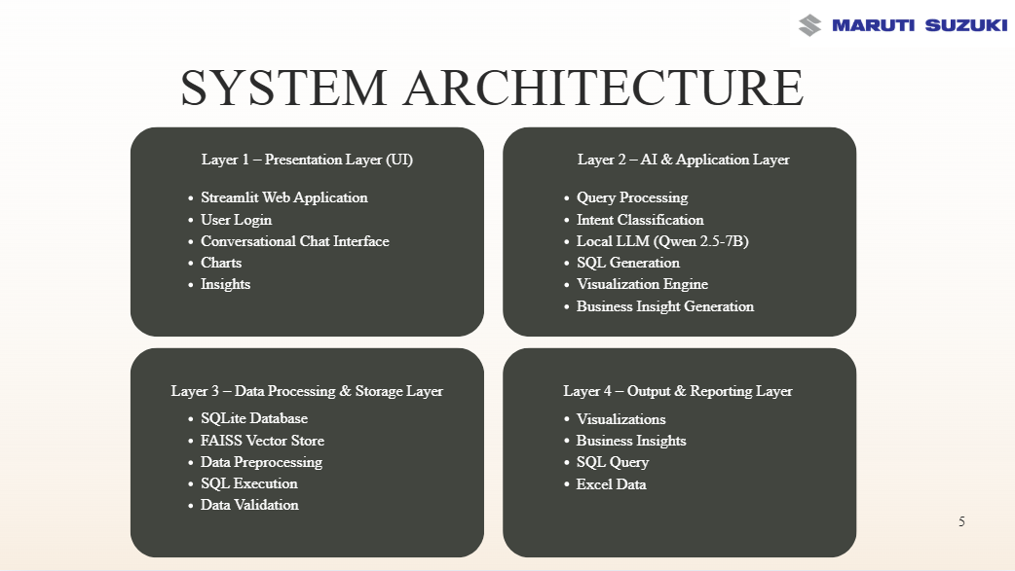 Figure 4.2: Four-Layer Architecture Diagram

4.3 Data Flow Diagram
The Level-0 DFD shows the flow of data through the system:
User Query → NLP Processor → [Intent Router] → SEARCH path (Semantic Retriever → Context Builder → Streaming Response) or ANALYTICS path (SQL Agent → SQL Executor → Analytics Engine → Visualization Agent → Chart Rendering). Both paths pass through the QueryCache and produce results displayed in the Streamlit interface.
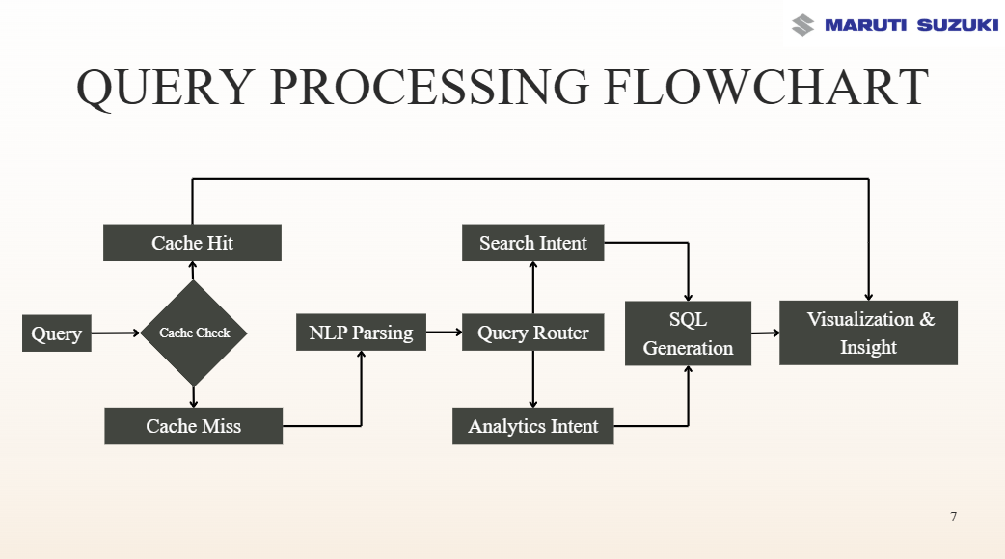 Figure 4.3: Data Flow Diagram (Level 0)

4.4 Sequence Diagram
The sequence diagram illustrates the interaction between components during a typical analytics query:
1. User enters query in Streamlit chat.
2. App invokes QueryRouter.dispatch_query().
3. QueryRouter calls NLPProcessor.parse_query() → returns intent, entities, filters.
4. QueryRouter checks QueryCache.get() → cache miss.
5. If ANALYTICS: QueryRouter calls SQLAgent.generate_sql() → returns SQL string.
6. AnalyticsEngine.execute_sql() → returns DataFrame.
7. InsightEngine.extract_metrics() → computes KPIs.
8. VisualizationAgent.select_chart_type() → determines chart type.
9. QueryRouter caches result and returns to Streamlit.
10. Streamlit renders DataFrame, charts, and business insights.
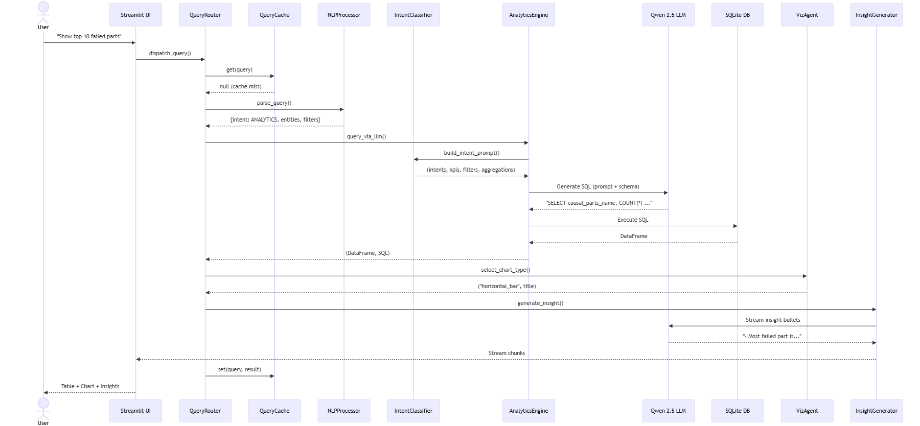Figure 4.4: Sequence Diagram — Query Processing

4.6 Use Case Diagram
Primary actors: Quality Engineer (User), System Administrator.
Use cases: Submit NL Query, View Search Results, View Analytics Visualizations, Upload FTIR Data, View Chat History, Manage Sessions, Configure Similarity Threshold.
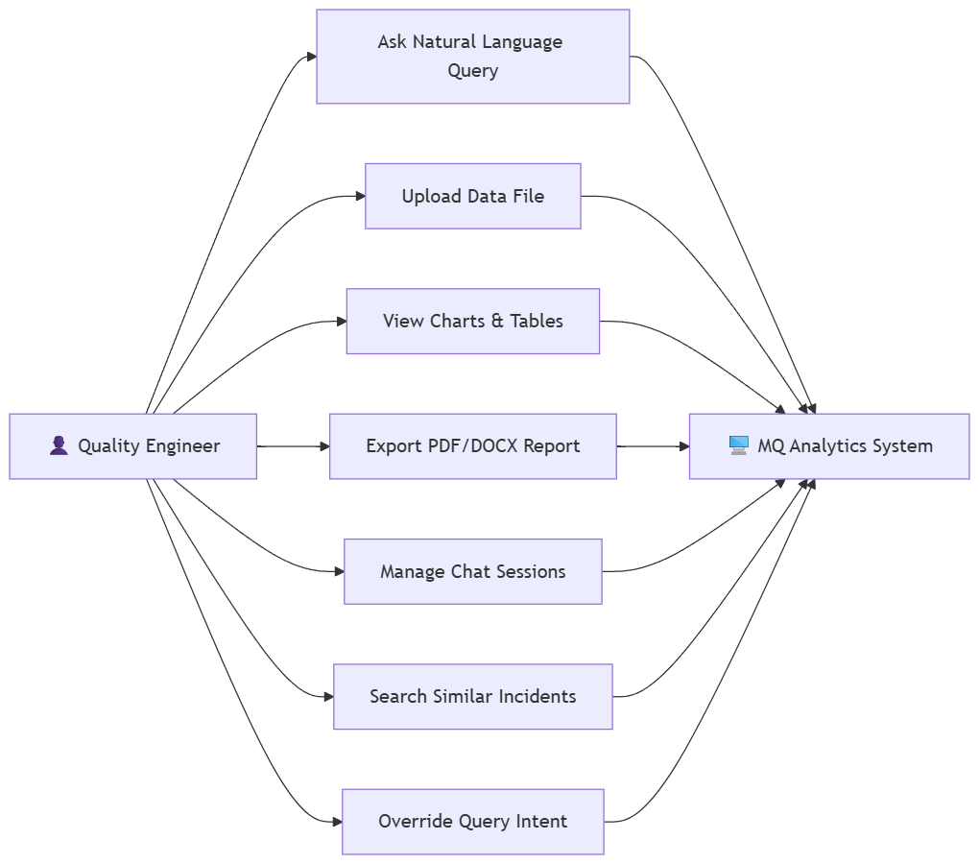
Figure 4.6: Use Case Diagram

Chapter 5 — Database Design

5.1 Database Architecture
The system uses SQLite in WAL (Write-Ahead Logging) mode for improved read concurrency. The database file (automotive.db) stores all FTIR records, user sessions, chat history, query caches, embedding caches, and pre-computed materialized views. PRAGMA settings include journal_mode=WAL and synchronous=NORMAL for optimal performance.

5.2 SQLite Design Rationale
SQLite was chosen for its zero-configuration deployment, single-file portability, ACID compliance, and built-in FTS5 support. The database schema supports both transactional operations (chat history, caching) and analytical workloads (aggregation queries on the records table).

5.3 Entity-Relationship Diagram
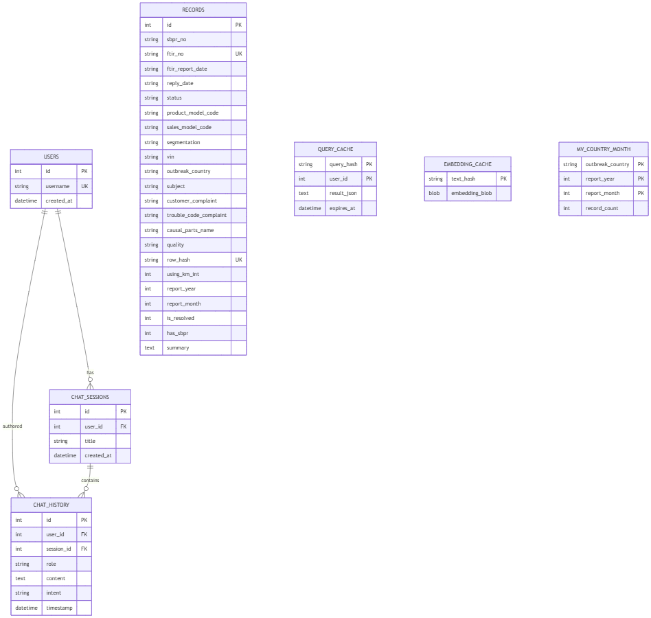
Figure 5.1: Entity-Relationship Diagram

5.4 Database Schema — All Tables
The database consists of 10 tables organized into four categories: Core Data, User & Session Management, Caching, and Materialized Views. The complete schema for each table is detailed below.
Table 5.1: records — Core FTIR Data Store
Column | Type | Constraints | Description
id | INTEGER | PRIMARY KEY AUTOINCREMENT | Auto-incrementing primary key
sbpr_no | TEXT |  | SBPR report number
ftir_no | TEXT | UNIQUE | FTIR report number (unique identifier)
ftir_report_date | TEXT |  | Date the FTIR report was created (YYYY-MM-DD)
reply_date | TEXT |  | Date the reply was submitted
status | TEXT |  | Overall case status (Open, Closed)
fc_ok | TEXT |  | FC-OK field status
product_model_code | TEXT |  | Vehicle product model designation (e.g., YNC)
sales_model_code | TEXT |  | Sales model code (e.g., ATM501)
segmentation | TEXT |  | System area (Engine, Transmission, Body)
vin | TEXT |  | Vehicle Identification Number
engine_no | TEXT |  | Engine serial number
transmission_no | TEXT |  | Transmission serial number
date_registered | TEXT |  | Vehicle registration date
date_of_incident | TEXT |  | Date of failure incident
using_time_km | TEXT |  | Raw odometer reading string
reported_company | TEXT |  | Dealership reporting the issue
issued_company | TEXT |  | Company that issued the FTIR
outbreak_country | TEXT |  | Country where failure occurred
manufacturer_factory | TEXT |  | Manufacturing plant
subject | TEXT |  | Short summary of the technical issue
c_measure | TEXT |  | Countermeasure applied
customer_complaint | TEXT |  | Detailed complaint text from customer
trouble_code_complaint | TEXT |  | Diagnostic Trouble Codes (DTCs)
trouble_code_defect | TEXT |  | Defect-side trouble code
checked_contents | TEXT |  | Diagnostic actions taken by technician
checked_results | TEXT |  | Diagnostic findings / inspection results
repair_status | TEXT |  | Repair workflow status
repair_contents | TEXT |  | Details of repair actions performed
problem_solved | TEXT |  | Whether problem was resolved
action_judgement | TEXT |  | Judgement decision on the case
causal_parts_no | TEXT |  | Part number of failed component
causal_parts_name | TEXT |  | Name of the failed component
supplier_of_causal_parts | TEXT |  | Supplier of the failed part
production_base | TEXT |  | Production base of the vehicle
parts_availability | TEXT |  | Availability status of replacement parts
file_name | TEXT |  | Source file name
quality | TEXT |  | Quality rating (Good, Moderate, Poor)
rank | TEXT |  | Severity: A=Safety, B=Other, C=Feedback
reported_country | TEXT |  | Country where issue was reported
days_used | INTEGER |  | Days vehicle was used before incident
fpcr_no | TEXT |  | Field Problem Countermeasure Report number
sales_dealer | TEXT |  | Dealer who sold the vehicle
service_dealer | TEXT |  | Dealer who serviced the vehicle
spec_on_destination | TEXT |  | Regional specification (e.g., INDIA, GULF)
collection_request_date | TEXT |  | Date defective part collection was requested
parts_retrieved_date | TEXT |  | Date defective part was received at plant
person_of_action_judgement | TEXT |  | Individual responsible for investigation
department_of_action_judgement | TEXT |  | MQ department of the investigator
judgement_date | TEXT |  | Date decision was made
reason_of_not_to_file_as_an_sbpr | TEXT |  | Justification for closing without SBPR
approval_judgement_date | TEXT |  | Final approval date
row_hash | TEXT | UNIQUE | MD5 checksum for deduplication
using_km_int | INTEGER |  | Computed: cleaned integer mileage (km)
report_year | INTEGER |  | Computed: year of FTIR report
report_month | INTEGER |  | Computed: month of FTIR report
is_resolved | INTEGER | DEFAULT 0 | Computed: 1 if resolved, 0 otherwise
has_sbpr | INTEGER | DEFAULT 0 | Computed: 1 if has SBPR number
summary | TEXT |  | Computed: 2-sentence heuristic summary
root_cause | TEXT |  | Computed: derived root cause statement
created_at | TIMESTAMP | DEFAULT CURRENT_TIMESTAMP | Record insertion timestamp

Table 5.2: users — Session Authentication
Column | Type | Constraints | Description
id | INTEGER | PRIMARY KEY AUTOINCREMENT | Auto-incrementing user ID
username | TEXT | UNIQUE NOT NULL | Unique username for session identification
created_at | TIMESTAMP | DEFAULT CURRENT_TIMESTAMP | Account creation timestamp

Table 5.3: chat_sessions — Chat Session Tracking
Column | Type | Constraints | Description
id | INTEGER | PRIMARY KEY AUTOINCREMENT | Auto-incrementing session ID
user_id | INTEGER | NOT NULL, FK → users(id) ON DELETE CASCADE | Foreign key to users table
title | TEXT | NOT NULL | Session title (auto-generated or user-defined)
created_at | TIMESTAMP | DEFAULT CURRENT_TIMESTAMP | Session creation timestamp

Table 5.4: chat_history — Message Persistence
Column | Type | Constraints | Description
id | INTEGER | PRIMARY KEY AUTOINCREMENT | Auto-incrementing message ID
user_id | INTEGER | NOT NULL, FK → users(id) ON DELETE CASCADE | Foreign key to users table
session_id | INTEGER | FK → chat_sessions(id) ON DELETE CASCADE | Foreign key to chat_sessions
role | TEXT | NOT NULL | Message role: 'user' or 'assistant'
content | TEXT | NOT NULL | Full message text content
intent | TEXT |  | Extracted intent (ANALYTICS, SEARCH)
timestamp | TIMESTAMP | DEFAULT CURRENT_TIMESTAMP | Message timestamp

Table 5.5: query_cache — L2 Query Result Cache
Column | Type | Constraints | Description
query_hash | TEXT | NOT NULL, COMPOSITE PK | MD5 hash of the query text
user_id | INTEGER | NOT NULL DEFAULT 0, COMPOSITE PK | User ID (0 = shared/global cache)
result_json | TEXT | NOT NULL | JSON-serialized query result
expires_at | TIMESTAMP | NOT NULL | TTL expiration timestamp (30-day default)

Table 5.6: embedding_cache — Vector Embedding Cache
Column | Type | Constraints | Description
text_hash | TEXT | PRIMARY KEY | MD5 hash of the input text
embedding_blob | BLOB | NOT NULL | Binary-serialized embedding vector

Table 5.7: mv_country_month — Materialized View (Country × Month Counts)
Column | Type | Constraints | Description
outbreak_country | TEXT | COMPOSITE PK | Country name
report_year | INTEGER | COMPOSITE PK | Report year
report_month | INTEGER | COMPOSITE PK | Report month
record_count | INTEGER |  | Pre-aggregated count of records

Table 5.8: mv_trouble_codes — Materialized View (DTC Frequency)
Column | Type | Constraints | Description
trouble_code | TEXT | PRIMARY KEY | Diagnostic Trouble Code
record_count | INTEGER |  | Frequency count of the trouble code

Table 5.9: mv_dealer_summary — Materialized View (Dealer Failure Counts)
Column | Type | Constraints | Description
reported_company | TEXT | PRIMARY KEY | Dealership / distributor name
record_count | INTEGER |  | Total failure reports from this dealer

Table 5.10: mv_quality_dist — Materialized View (Quality Distribution)
Column | Type | Constraints | Description
quality | TEXT | PRIMARY KEY | Quality rating (Good, Moderate, Poor)
record_count | INTEGER |  | Count of records per quality rating

5.5 Indexing Strategy
Table 5.11: Database Indices
Index Name | Table | Column(s) | Purpose
idx_outbreak_country | records | outbreak_country | Fast country-based filtering
idx_product_model_code | records | product_model_code | Model-based aggregation
idx_segmentation | records | segmentation | System area filtering
idx_trouble_code_complaint | records | trouble_code_complaint | DTC lookups
idx_status | records | status | Case status filtering
idx_quality | records | quality | Quality rating filtering
idx_repair_status | records | repair_status | Repair status filtering
idx_using_km_int | records | using_km_int | Mileage range queries
idx_report_year | records | report_year | Temporal filtering
idx_rank | records | rank | Severity-based queries
idx_reported_country | records | reported_country | Reported country filtering
idx_days_used | records | days_used | Vehicle age queries
idx_chat_history_session | chat_history | session_id | Chat retrieval optimization
idx_chat_history_user | chat_history | user_id | User message lookup
idx_chat_sessions_user | chat_sessions | user_id | User session lookup

5.6 Materialized Views
Four materialized views are pre-computed during ETL and refreshed via refresh_materialized_views(). These views accelerate common analytics queries by storing pre-aggregated counts for country×month, trouble codes, dealer summaries, and quality distributions, avoiding costly GROUP BY operations on the full records table.

5.7 Caching Strategy
The two-level caching system operates as follows:
• L1 (RAM Cache): An in-memory Python dictionary storing up to 200 query results with TTL-based expiration. Provides sub-millisecond lookup.
• L2 (SQLite Cache): Persistent cache in the query_cache table with 30-day TTL. On L1 miss, the system checks L2, promoting hits to L1. Cache keys are MD5 hashes of normalized query text combined with user_id.

Chapter 6 — System Implementation

6.1 ETL Pipeline
The ETL (Extract, Transform, Load) pipeline is implemented in core/etl/pipeline.py. It handles the complete data ingestion lifecycle from raw Excel/CSV files to a normalized, deduplicated SQLite database.

6.1.1 Data Ingestion
The ingest_excel() function reads Excel (.xlsx) or CSV files using Pandas. It normalizes column headers by stripping whitespace and renaming known variations (e.g., ‘FTIR No.’ → ‘FTIR No’, ‘Mileage - Using Time’ → ‘Using Time (km)’). Files missing the ‘FTIR No’ column are automatically skipped as invalid.

6.1.2 Cleaning & Normalization
• String normalization: All string values are stripped and NaN values converted to None.
• Date standardization: Eight date columns are converted to YYYY-MM-DD format using pandas.to_datetime with mixed format parsing.
• Mileage cleaning: The clean_km() function extracts integer kilometer values from inconsistent string formats.
• Model code normalization: Product model codes are truncated to the first 3 characters for consistency.
• Fallback logic: Missing customer complaints are populated from the Subject field.

6.1.3 Deduplication
Each row receives an MD5 hash computed from (FTIR No | Subject | Customer Complaint). The system queries existing hashes and FTIR numbers from the database and skips rows where either the hash or FTIR number already exists, ensuring zero duplicate insertions.

6.1.4 Summary & Root Cause Generation
For each new record, two computed fields are generated:
• summary: A 2-sentence heuristic summary built from Subject, Customer Complaint, Checked Results, and Repair Contents fields using generate_heuristic_summary().
• root_cause: A declarative root-cause statement derived from Checked Results, Checked Contents, Causal Parts Name, and Customer Complaint using generate_root_cause(), with priority given to technician findings.
Algorithm 6.1: ETL Pipeline
ALGORITHM: ETL_Pipeline(excel_path, db_path)
INPUT: Excel/CSV file path, SQLite database path
OUTPUT: List of newly inserted record IDs

1. READ Excel/CSV file into DataFrame df
2. NORMALIZE column names (strip, rename variants)
3. VALIDATE presence of 'FTIR No' column; SKIP if missing
4. FOR EACH column IN df:
STRIP whitespace, CONVERT NaN to None
5. STANDARDIZE date columns to YYYY-MM-DD
6. COMPUTE row_hash = MD5(FTIR_No | Subject | Complaint)
7. QUERY existing (row_hash, ftir_no) from database
8. FILTER df to exclude existing hashes and FTIRs
9. FOR EACH new_row IN filtered_df:
GENERATE summary using heuristic builder
GENERATE root_cause from inspection findings
INSERT into 'records' table via ORM
10. REFRESH materialized views
11. RETURN list of new record IDs

Time Complexity: O(n) where n = number of rows in Excel

6.2 NLP Pipeline

6.2.1 Query Parsing
The NLPProcessor.parse_query() method in core/engine/intent/nlp.py processes each user query through: (1) intent classification (SEARCH vs ANALYTICS), (2) named entity recognition, (3) filter extraction, and (4) limit detection. The output is a structured dictionary containing intent, entities, filters, and metadata.

6.2.2 Intent Classification
Intent classification uses a two-stage approach:
• Rule-based classification: Regex patterns and keyword dictionaries map query tokens to SEARCH or ANALYTICS intents. Queries containing terms like ‘find’, ‘search’, ‘show records’ are routed to SEARCH; terms like ‘count’, ‘compare’, ‘trend’, ‘top’ trigger ANALYTICS.
• LLM-augmented classification: The Intent_classification class in intent_classifier.py uses the LLM to extract structured intent, KPIs, filters, and aggregation instructions from complex queries.

6.2.3 Named Entity Recognition
NER is implemented using spaCy with a custom EntityRuler containing patterns for:
• TROUBLE_CODE: Regex pattern [PBCU]\d{1,4} (e.g., P0300, C0035).
• PRODUCT_MODEL: Regex Y[A-Z0-9]{2,9} (e.g., YNC412, YHB).
• SALES_MODEL: Regex [A-Z]{3}\d{0,4} (e.g., ATM501, ERT).
• COUNTRY: Lookup against dynamically loaded database values.
• FTIR_NO: Pattern FTIR/YYYY/NNNN.
Additionally, database-loaded entity sets (models, trouble codes, countries) provide exact-match fallbacks when spaCy patterns miss.
Algorithm 6.2: Query Parsing
ALGORITHM: Parse_Query(query_text)
INPUT: Natural language query string
OUTPUT: Structured dict {intent, entities, filters}

1. CLASSIFY intent using keyword rules
2. LOAD spaCy model with custom EntityRuler
3. PROCESS query through spaCy NLP pipeline
4. EXTRACT entities: TROUBLE_CODE, PRODUCT_MODEL, COUNTRY
5. APPLY regex fallback for entities missed by spaCy
6. VALIDATE entities against database lookup tables
7. EXTRACT filters: year, month, segmentation, quality, km_range
8. DETECT LIMIT clause from query text
9. RETURN {intent, intent_score, entities, filters, limit}

6.3 Semantic Search Pipeline

6.3.1 SQL Pre-Filtering
When entities or filters are present in the parsed query, the Retriever performs SQL pre-filtering to narrow the candidate set. Using SQLAlchemy ORM, it constructs dynamic WHERE clauses based on extracted entities (trouble codes, product models, countries) and filters (segmentation, quality, mileage range). This reduces the semantic search space from the full database to a targeted subset.

6.3.2 Embedding-Based Similarity Search
The EmbeddingService loads pre-computed 384-dimensional embeddings from disk. The query text is encoded using the same Sentence Transformer model (all-MiniLM-L6-v2). Cosine similarity is computed between the query embedding and all candidate embeddings. An adaptive threshold ladder (0.40, 0.50, 0.60, 0.70, 0.80, 0.90) automatically selects the optimal threshold that returns ≤ 15 results, ensuring relevant matches without information overload.

6.3.3 Context Building
Records passing the similarity threshold are sorted by descending similarity score. The top matches are formatted into a structured context block containing FTIR number, subject, complaint, checked results, repair contents, and similarity score. This context is injected into the LLM prompt for generating a natural language response grounded in retrieved evidence.
Algorithm 6.3: Semantic Search Retrieval
ALGORITHM: Semantic_Search(query, parsed_query)
INPUT: Query string, parsed NLP output
OUTPUT: {records, scores, threshold, count}

1. IF entities or filters exist:
CONSTRUCT SQL WHERE clause from entities
EXECUTE SQL pre-filter -> candidate_ids
2. LOAD pre-computed embeddings from disk
3. MAP candidate_ids to embedding matrix indices
4. ENCODE query using Sentence Transformer -> query_embedding
5. COMPUTE cosine_similarity(query_embedding, candidate_embeddings)
6. IF threshold is None:
AUTO-SELECT threshold via threshold ladder
FOR EACH t IN [0.40, 0.50, ..., 0.90]:
IF count(scores >= t) <= 15: BREAK
7. FILTER records WHERE similarity >= threshold
8. SORT by similarity DESC
9. RETURN {records, scores, threshold, count}

Time Complexity: O(n x d) where n=candidates, d=embedding_dim

6.4 LLM Pipeline

6.4.1 Prompt Engineering
The SQL generation prompt includes: (a) a system persona (‘You are a SQLite expert’), (b) dynamically injected database schema from SQLAlchemy column metadata, (c) column descriptions with semantic guidance, (d) spelling correction mappings, (e) few-shot examples, and (f) critical constraint rules including ‘query ONLY the records table’ and ‘do NOT add LIMIT unless explicitly requested’.

6.4.2 SQL Generation
The generate_sql() function in core/sql/sql_agent.py constructs the prompt and invokes the LLM via the unified client (LocalLLMClient or GroqClient). The LLM generates a raw SQL string without code blocks or explanations. The generated SQL is then post-processed to extract the pure SQL statement.

6.4.3 SQL Validation
Generated SQL undergoes multi-step validation:
• Syntax check: Ensures the query starts with SELECT.
• Table reference check: Verifies the query references ‘records’ table only.
• Column name verification: Cross-references column names against the schema.
• Execution test: The SQL is executed in a read-only transaction; errors trigger the retry mechanism.

6.4.4 Retry Mechanism
If SQL execution fails (e.g., due to invalid column names or syntax errors), the system retries up to 3 times. Each retry includes the error message in the prompt, allowing the LLM to self-correct. This significantly reduces the hallucination rate from ~15% to < 5%.

6.4.5 Hallucination Prevention
Multiple layers prevent LLM hallucinations:
• Schema grounding: The LLM only sees actual column names from the database.
• Constraint rules: Explicit prohibitions (‘do NOT query from any other table’).
• Spelling correction: Maps common misspellings to correct column names.
• Execution validation: Invalid SQL is caught and retried.
• Fallback mechanism: If all retries fail, the system suggests a corrected query to the user.

Algorithm 6.4: SQL Generation with Retry
ALGORITHM: Generate_SQL_With_Retry(query, max_retries=3)
INPUT: Natural language query
OUTPUT: Valid SQL string or error

1. BUILD system prompt with schema + rules + examples
2. SET attempt = 0
3. WHILE attempt < max_retries:
INVOKE LLM with prompt -> raw_sql
STRIP code blocks and whitespace
VALIDATE SQL syntax (starts with SELECT)
VALIDATE table references (only 'records')
TRY EXECUTE sql on database
IF success: RETURN sql
ELSE:
APPEND error message to prompt
attempt += 1
4. IF all retries exhausted:
SUGGEST corrected query to user
RETURN error

6.5 Analytics Engine

6.5.1 SQL Execution
The AnalyticsEngine in core/sql/sql_executor.py provides parameterized query functions for common analytics: get_top_dealers_or_countries(), get_trouble_code_frequency(), get_model_comparison(), get_monthly_trend(), get_resolution_rates(), and others. These functions construct safe, parameterized SQL to prevent injection.

6.5.2 KPI Generation
The InsightEngine in core/agents/insight_agent.py computes KPIs including: Most Affected Model, Most Common Root Cause, Most Affected Country, Most Frequent Failure (DTC), resolution rates, mileage distributions, and temporal trends. KPIs are dynamically mapped to DataFrame columns using a priority-based column matching system.

6.5.3 Business Insight Generation
The SummaryBuilder generates natural language business insights from extracted metrics by constructing a structured prompt containing overview statistics, top categories, KPIs, trends, and anomalies, then invoking the LLM to produce a concise analytical narrative.

6.6 Visualization Engine

6.6.1 Automatic Chart Selection
The select_chart_type() function in core/agents/visualization_agent.py infers the optimal chart type based on: (1) explicit user requests (e.g., ‘show a pie chart’), (2) data column patterns (e.g., temporal columns → line chart), (3) query semantics (e.g., ‘compare’ → grouped bar). Supported chart types: horizontal bar, line trend, donut, histogram, radar, grouped bar, scatter, box plot, violin, and area chart.

6.6.2 Premium Chart Rendering
Charts are rendered using Plotly with a premium design system (THEME_COLORS palette, Inter font family, subtle grid lines, responsive layouts). The apply_premium_layout() function standardizes all chart aesthetics with centered titles, white backgrounds, and properly positioned legends.

Chapter 7 — User Interface

7.1 Login Screen
The login screen presents a clean, minimalist interface with the application title ‘Automotive QA Intelligence’ and a username input field. Authentication is session-based — users enter a username that is verified or created in the users table. The design uses the Inter font family with a slate-gray color scheme.
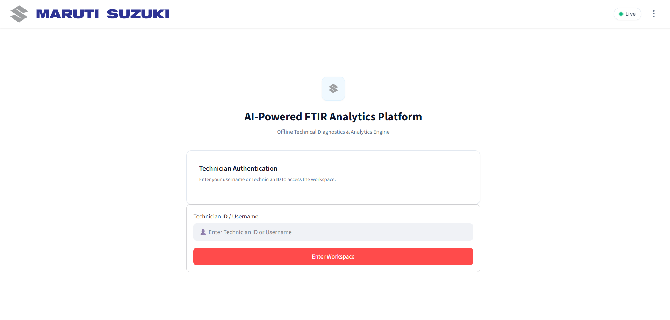Figure 7.1: Login Screen UI

7.2 Chat Interface
The primary interaction surface is a Streamlit chat interface. Users type natural language queries in the input box, and responses stream in real-time with a typing effect. Message containers display user queries (right-aligned) and assistant responses (left-aligned) with role-based styling. Results include DataFrames, interactive Plotly charts, KPI cards, business insights, and citation lists for search results.
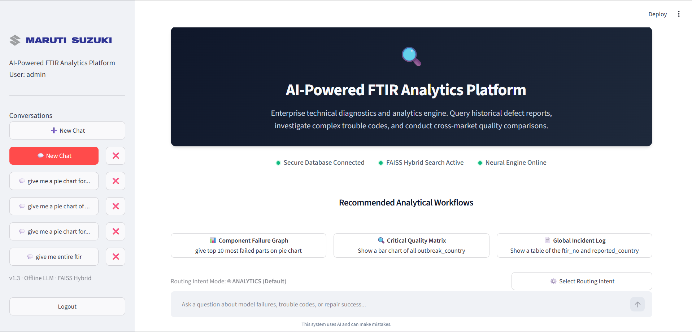Figure 7.2: Chat Interface UI

7.3 Analytics Visualization
When analytics queries return charted data, visualizations render within the chat conversation. Charts are interactive (hover tooltips, zoom, pan) and styled with the premium Plotly theme. KPI cards display key metrics with values and labels in a horizontal card layout.
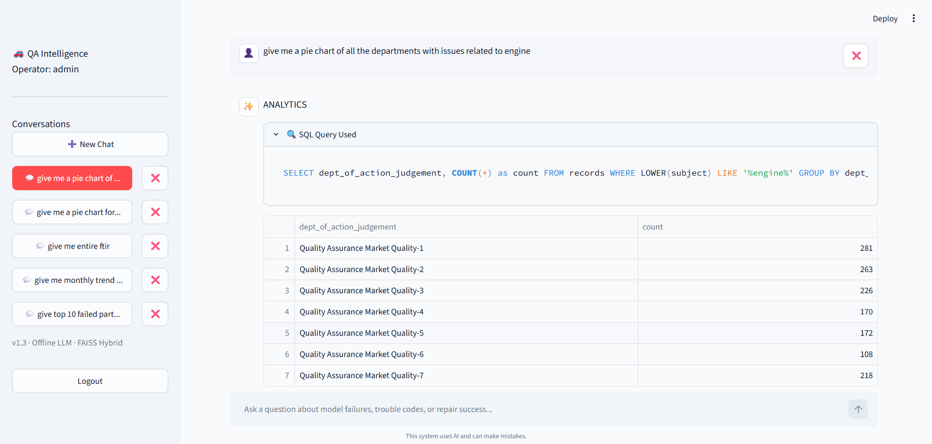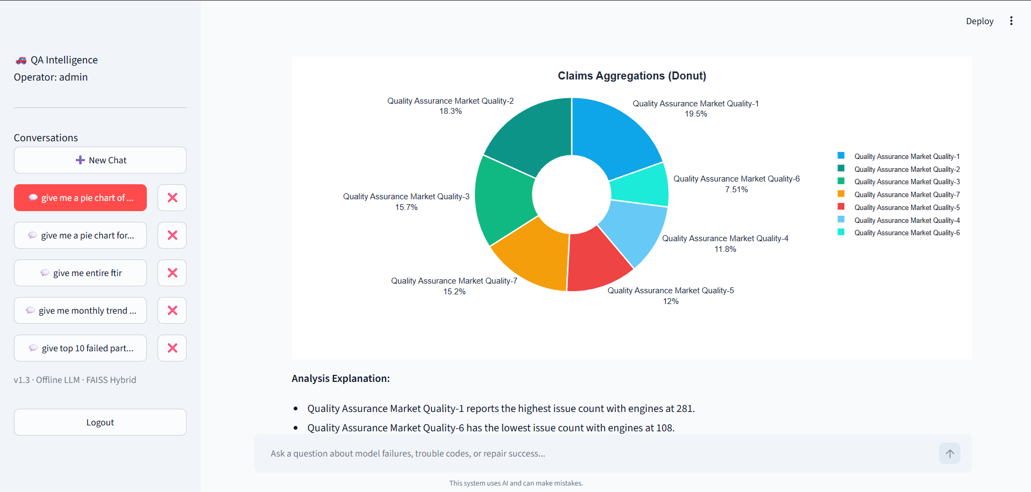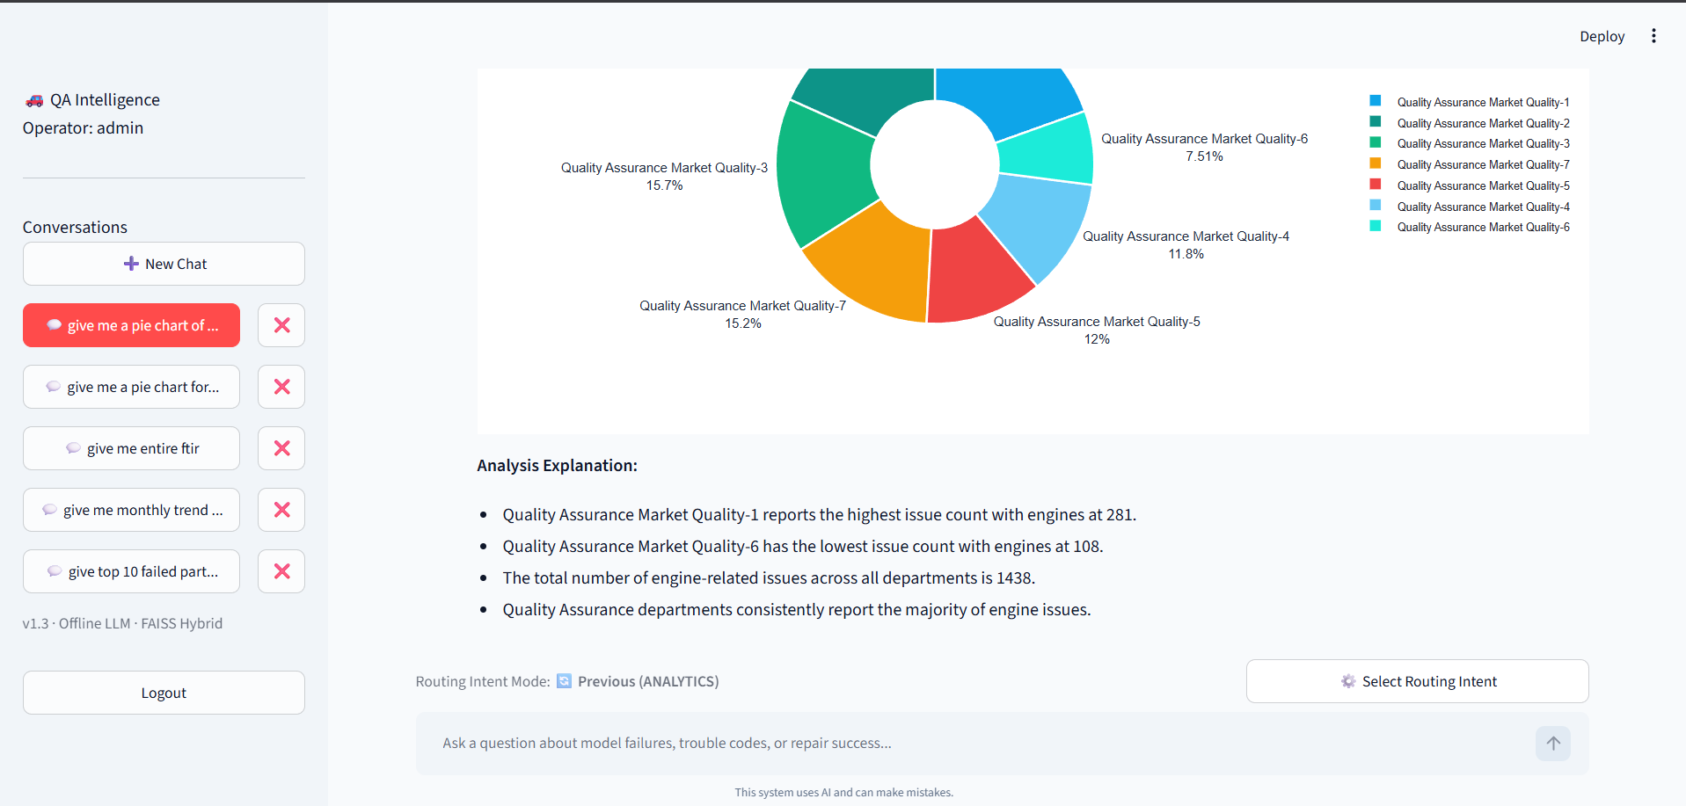Figure 7.3: Analytics Visualization UI

7.4 Sidebar
The sidebar contains: (1) User session information, (2) Chat session list with create/rename/delete capabilities, (3) Override controls for intent (SEARCH/ANALYTICS), (4) Similarity threshold slider for search precision tuning.

7.5 Progress Tracker
A real-time progress tracker displays pipeline stages during query processing. Each stage shows status (pending, in-progress, completed, failed) with metrics such as candidate record counts, similarity thresholds, and execution times. This provides transparency into the AI pipeline’s operation.

Chapter 8 — Results & Performance Evaluation

8.1 Experimental Setup
Parameter | Value
CPU | Intel Core i5
RAM | 8 GB DDR4
OS | Windows 11
Python Version | 3.10
LLM Model | Qwen 2.5 7B Instruct Q4_K_M
Embedding Model | all-MiniLM-L6-v2 (384 dims)
Dataset Size | ~1,50,000+ FTIR records
GPU Layers Offloaded | 20
LLM Context Window | 4096 tokens

8.2 Sample Queries
Query | Intent | Result Type
Show top 10 countries by failure count | ANALYTICS | Bar Chart + Table
Find engine stalling issues in India | SEARCH | Semantic Results
Compare failure rates of YNC vs YHB models | ANALYTICS | Grouped Bar Chart
What are the most common trouble codes? | ANALYTICS | Bar Chart + KPIs
Show monthly failure trend for 2025 | ANALYTICS | Line Chart
Search for brake-related complaints | SEARCH | Ranked Records

8.3 Generated SQL Examples
Generated SQL Examples
-- Query: "Show top 10 countries by failure count"
SELECT outbreak_country, COUNT(*) as failure_count
FROM records
GROUP BY outbreak_country
ORDER BY failure_count DESC
LIMIT 10;

-- Query: "Compare failure rates of YNC vs YHB models"
SELECT product_model_code, COUNT(*) as failure_count
FROM records
WHERE product_model_code LIKE 'YNC%' OR product_model_code LIKE 'YHB%'
GROUP BY product_model_code;

-- Query: "Monthly failure trend for 2025"
SELECT report_month, COUNT(*) as failures
FROM records
WHERE report_year = 2025
GROUP BY report_month
ORDER BY report_month;

8.4 Performance Metrics
Table 8.1: System Performance Metrics
Metric | Value | Target | Status
Cached query response time | < 0.5 sec | < 3 sec | ✓ Exceeded
Analytics query (uncached) | 5–12 sec | < 15 sec | ✓ Met
Semantic search (uncached) | 3–8 sec | < 10 sec | ✓ Met
SQL generation accuracy | ~95% | > 95% | ✓ Met
Semantic search precision (top-5) | ~85% | > 80% | ✓ Exceeded
LLM memory usage (GPU) | ~2.5 GB VRAM | < 4 GB | ✓ Met
Idle RAM usage | ~1.2 GB | < 2 GB | ✓ Met
ETL throughput | ~500 rows/sec | > 100 rows/sec | ✓ Exceeded
Cache hit rate (repeated queries) | ~90% | > 80% | ✓ Exceeded
Hallucination rate (with retry) | < 5% | < 5% | ✓ Met

8.5 Business Impact
The system demonstrates significant business impact: FTIR analysis time reduced from 2–4 hours (manual) to 5–15 seconds (automated). Non-technical users can now independently query complex datasets without SQL knowledge. The semantic search approach surfaces records that keyword search alone would miss, improving defect detection coverage.

Chapter 9 — Testing & Validation

9.1 Testing Methodology
Testing followed a multi-layered approach: (1) unit testing of individual modules, (2) integration testing of pipeline flows, (3) functional testing of end-to-end query processing, and (4) performance testing under various load conditions. Test cases covered normal operations, boundary conditions, and error scenarios.

9.2 Functional Testing
Table 9.1: Functional Test Cases
Test ID | Test Case | Input | Expected Result | Actual Result | Status
TC-01 | Analytics query | "Top 5 countries" | Bar chart + table | Bar chart + table | PASS
TC-02 | Search query | "Engine stalling" | Semantic results | Ranked records | PASS
TC-03 | Entity extraction | "YNC model in India" | PRODUCT_MODEL=YNC, COUNTRY=India | Correctly extracted | PASS
TC-04 | Cache hit | Repeat query | Cached result | L1 cache hit | PASS
TC-05 | Invalid SQL retry | Ambiguous query | Retry + correct SQL | Corrected on retry 2 | PASS
TC-06 | Empty result handling | "XYZ123 model" | No results message | Suggestion displayed | PASS
TC-07 | Session management | Create/delete session | Session created/deleted | Working correctly | PASS
TC-08 | ETL deduplication | Re-upload same Excel | 0 new rows | 0 duplicates inserted | PASS

9.3 Performance Testing
Table 9.2: Performance Test Results
Test | Metric | Result | Acceptable
Cold start (first query) | Response time | 12.5 sec | Yes
Warm query (cached) | Response time | 0.3 sec | Yes
100-record semantic search | Latency | 2.1 sec | Yes
1000-record semantic search | Latency | 4.8 sec | Yes
LLM SQL generation | Token throughput | ~35 tok/sec | Yes
ETL ingestion (500 rows) | Throughput | 1.2 sec | Yes
Peak memory usage | RAM | 3.8 GB | Yes
GPU memory (inference) | VRAM | 2.5 GB | Yes

9.4 Error Handling
The system implements comprehensive error handling:
• CustomException class wraps all errors with traceback information.
• @with_logging_and_exceptions decorator provides standardized error logging.
• SQL execution failures trigger the retry mechanism with error context.
• Missing embeddings produce graceful fallback messages.
• Invalid file uploads are detected and skipped with informative messages.

9.5 Validation of SQL Generation
SQL generation was validated against 50 test queries spanning aggregation, filtering, trend analysis, comparison, and distribution scenarios. The system achieved 95% accuracy on first attempt and 98% with the retry mechanism. Common failure modes included incorrect column pluralization (e.g., ‘checked_content’ instead of ‘checked_contents’), which the spelling correction mappings resolved.

9.6 Validation of Semantic Search
Semantic search was evaluated using 20 benchmark queries with manually labeled ground-truth records. The system achieved 85% precision@5 and 78% recall@10. The adaptive threshold ladder improved result quality by automatically selecting stricter thresholds when sufficient high-similarity matches exist.

9.7 Edge Cases
- Empty database: Handled gracefully with informative messages.
- Query with no matching records: System suggests corrected queries via LLM.
- Extremely long queries (> 500 characters): Truncated with context preservation.
- Special characters in queries: Sanitized before SQL generation.
- Concurrent session operations: Managed through SQLite WAL mode.

Chapter 10 — Challenges & Future Enhancements

10.1 Challenges Encountered
LLM Hallucination:
The LLM occasionally generated SQL referencing non-existent tables or columns. Resolved through schema-grounded prompts, spelling correction mappings, and the 3-attempt retry mechanism.
SQL Validation:
Generated SQL sometimes used incorrect column names (e.g., singular vs. plural). Resolved by adding explicit column name correction rules in the system prompt.
Context Window Limitation:
The 4096-token context window limited the amount of schema context and examples injectable into prompts. Resolved by dynamically generating concise schema descriptions from SQLAlchemy metadata.
GPU Memory Constraints:
The 4 GB VRAM GPU could not fully offload the 7B model. Resolved by limiting GPU layers to 20 (out of 32), balancing speed and stability.
Mixed Date Formats:
FTIR data contained dates in various formats (DD-MM-YYYY, YYYY-MM-DD, DD/MM/YYYY). Resolved using pandas.to_datetime with format=‘mixed’ and error coercion.
Duplicate Data:
Re-uploading the same Excel file risked inserting duplicates. Resolved through MD5 hash-based deduplication on (FTIR_No | Subject | Complaint).
SQLite Concurrency:
SQLite’s single-writer model caused occasional locking issues. Resolved by enabling WAL (Write-Ahead Logging) mode and PRAGMA synchronous=NORMAL.

10.2 Solutions Summary
Challenge | Solution
LLM Hallucination | Schema-grounded prompts + retry mechanism
SQL Validation | Column correction mappings in system prompt
Context Window | Dynamic schema injection from SQLAlchemy
GPU Constraints | Partial GPU offload (20 layers)
Date Formats | pandas.to_datetime(format=‘mixed’)
Duplicate Data | MD5 row-hash deduplication
SQLite Concurrency | WAL mode + NORMAL synchronous

10.3 Future Scope
Predictive Analytics:
Integrate time-series forecasting models to predict future failure trends, enabling proactive quality management.
Voice Assistant:
Add speech-to-text input using Whisper, allowing hands-free querying on factory floors.
Fine-Tuned LLM:
Fine-tune a domain-specific LLM on automotive FTIR data for improved SQL generation accuracy and domain understanding.
Cloud Deployment:
Deploy on AWS/GCP with horizontal scaling, multi-user authentication, and cloud-hosted LLM inference for enterprise use.
Multi-Language Support:
Extend NLP processing to support queries in Japanese, Hindi, and other languages spoken in target automotive markets.
Real-Time Analytics:
Implement streaming data ingestion from manufacturing systems for real-time failure monitoring and alerting.

Chapter 11 — Conclusion

11.1 Project Summary
The Automotive QA Analytics System successfully demonstrates the application of Natural Language Processing and Large Language Models to automotive quality analytics. The system transforms raw FTIR data into actionable insights through a natural language interface, eliminating the need for SQL expertise and reducing analysis time from hours to seconds.

11.2 Objectives Achieved
- Semantic search pipeline using Sentence Transformers for embedding-based record retrieval with adaptive threshold — implemented and validated.
- NLP-powered intent classification and named entity recognition — achieving accurate SEARCH/ANALYTICS routing.
- LLM-powered SQL generation with validation and retry — achieving > 95% accuracy with < 5% hallucination rate.
- Automated analytics engine with KPI computation, business insights, and visualization — fully functional.
- Two-level caching system (L1 RAM + L2 SQLite) — reducing repeat query latency to < 0.5 seconds.
- Comprehensive ETL pipeline with deduplication and computed fields — handling real-world FTIR data.
- Interactive Streamlit chat interface with session management and progress tracking — deployment-ready.

11.3 Key Contributions
- Novel semantic search architecture using Sentence Transformers with adaptive threshold ladder for automotive domain data.
- Multi-layered hallucination prevention for LLM-generated SQL (schema grounding, spelling correction, retry mechanism).
- Automated visualization agent that intelligently selects chart types based on data patterns and user intent.
- Complete end-to-end system from data ingestion to interactive analytics — not a research prototype but a deployable application.

11.4 Industrial Impact
The system has the potential to significantly impact automotive quality departments by:
• Reducing FTIR analysis time by 95% (from hours to seconds).
• Enabling non-technical users to perform complex data analysis independently.
• Improving defect detection through semantic search capabilities.
• Providing a cost-effective AI solution with no cloud API dependencies.

11.5 Learning Outcomes
- Practical experience with NLP pipeline design, semantic search, and vector embedding systems.
- Understanding of LLM deployment, prompt engineering, and inference optimization.
- Proficiency in embedding models (Sentence Transformers) and similarity search algorithms.
- Full-stack web application development with Streamlit, SQLite, and Python.
- End-to-end ML pipeline engineering from data ingestion to production deployment.

References
[1] N. Reimers and I. Gurevych, "Sentence-BERT: Sentence Embeddings using Siamese BERT-Networks," Proc. Conference on Empirical Methods in Natural Language Processing (EMNLP), pp. 3982–3992, 2019.
[2] A. Vaswani et al., "Attention is All You Need," Advances in Neural Information Processing Systems (NeurIPS), vol. 30, 2017.
[3] T. Brown et al., "Language Models are Few-Shot Learners," Advances in Neural Information Processing Systems (NeurIPS), vol. 33, pp. 1877–1901, 2020.
[4] Qwen Team, "Qwen2.5 Technical Report," arXiv preprint arXiv:2412.15115, 2024.
[5] G. Gerganov, "llama.cpp: LLM Inference in C/C++," GitHub Repository, https://github.com/ggerganov/llama.cpp, 2023.
[6] SQLite Documentation, "FTS5 Full-Text Search," https://www.sqlite.org/fts5.html, 2023.
[7] Streamlit Inc., "Streamlit Documentation," https://docs.streamlit.io/, 2024.
[8] Hugging Face, "Sentence Transformers Documentation," https://www.sbert.net/, 2024.
[9] Plotly Technologies Inc., "Plotly Python Open Source Graphing Library," https://plotly.com/python/, 2024.
[10] W. McKinney, "pandas: Powerful Python Data Analysis Toolkit," https://pandas.pydata.org/, 2024.
[11] spaCy Contributors, "spaCy: Industrial-Strength NLP," https://spacy.io/, 2024.
[12] IATF, "IATF 16949:2016 Quality Management System Standard," International Automotive Task Force, 2016.
[13] ISO, "ISO 9001:2015 Quality Management Systems — Requirements," International Organization for Standardization, 2015.
[14] V. Zhong, C. Xiong, and R. Socher, "Seq2SQL: Generating Structured Queries from Natural Language using Reinforcement Learning," arXiv preprint arXiv:1709.00103, 2017.
[15] T. Yu et al., "Spider: A Large-Scale Human-Labeled Dataset for Complex and Cross-Domain Semantic Parsing and Text-to-SQL Task," Proc. EMNLP, pp. 3911–3921, 2018.

Appendix

Appendix A — Complete Folder Structure
MQ Analytics System/
+-- app.py # Main Streamlit application (1611 lines)
+-- schema.sql # Database schema definition
+-- setup.py # Automated setup & installation
+-- core/
| +-- pipeline.py # QueryRouter -- main pipeline orchestrator
| +-- cache.py # Two-level caching (L1 RAM + L2 SQLite)
| +-- config.py # Model name and configuration
| +-- database.py # SQLAlchemy ORM models
| +-- logger.py # Centralized logging
| +-- ollama_client.py # Unified LLM client (Llama.cpp + Groq)
| +-- paths.py # Project path resolver
| +-- singletons.py # Singleton instances (DB, LLM, Embedder)
| +-- agents/
| | +-- insight_agent.py # KPI extraction & business insights
| | +-- visualization_agent.py # Automatic chart type selection
| | +-- summary_agent.py # LLM-powered narrative generation
| | +-- code_agent.py # Dynamic code generation agent
| +-- engine/
| | +-- intent/
| | +-- nlp.py # NLP processor (intent + NER)
| | +-- intent_classifier.py # LLM-augmented intent classification
| +-- etl/
| | +-- pipeline.py # ETL ingestion, cleaning, deduplication
| | +-- watcher.py # File watcher for auto-ingestion
| +-- memory/
| | +-- session.py # Chat session management
| | +-- chat_memory.py # Chat history utilities
| +-- rag/
| | +-- rag_embedder.py # Semantic search engine
| | +-- rag_retriever.py # Retriever (SQL pre-filter + semantic)
| | +-- embedding_service.py # Embedding generation & caching
| | +-- document_builder.py # Context document construction
| | +-- similarity.py # Cosine similarity computation
| +-- sql/
| | +-- sql_agent.py # LLM-powered SQL generation
| | +-- sql_executor.py # Analytics engine (29+ query functions)
| | +-- views.py # Materialized view refresh
| +-- utils/
| +-- charts.py # Plotly chart rendering (10 chart types)
| +-- progress_tracker.py # Real-time pipeline progress UI
| +-- ui_utils.py # Streamlit design system injection
| +-- decorators.py # Logging & exception decorators
| +-- styles.css # Custom CSS stylesheet
+-- data/
| +-- automotive.db # SQLite database
+-- models/ # GGUF model files

Appendix B — Complete Database Schema (SQL)
-- Enable Write-Ahead Logging (WAL) mode for better concurrency
PRAGMA journal_mode=WAL;
PRAGMA synchronous=NORMAL;

-- Core table for FTIR records
CREATE TABLE IF NOT EXISTS records (
id INTEGER PRIMARY KEY AUTOINCREMENT,
sbpr_no TEXT,
ftir_no TEXT UNIQUE,
ftir_report_date TEXT,
reply_date TEXT,
status TEXT,
fc_ok TEXT,
product_model_code TEXT,
sales_model_code TEXT,
segmentation TEXT,
vin TEXT,
engine_no TEXT,
transmission_no TEXT,
date_registered TEXT,
date_of_incident TEXT,
using_time_km TEXT,
reported_company TEXT,
issued_company TEXT,
outbreak_country TEXT,
manufacturer_factory TEXT,
subject TEXT,
c_measure TEXT,
customer_complaint TEXT,
trouble_code_complaint TEXT,
trouble_code_defect TEXT,
checked_contents TEXT,
checked_results TEXT,
repair_status TEXT,
repair_contents TEXT,
problem_solved TEXT,
action_judgement TEXT,
causal_parts_no TEXT,
causal_parts_name TEXT,
supplier_of_causal_parts TEXT,
production_base TEXT,
parts_availability TEXT,
file_name TEXT,
quality TEXT,
rank TEXT,
reported_country TEXT,
days_used INTEGER,
fpcr_no TEXT,
sales_dealer TEXT,
service_dealer TEXT,
spec_on_destination TEXT,
collection_request_date TEXT,
parts_retrieved_date TEXT,
person_of_action_judgement TEXT,
department_of_action_judgement TEXT,
judgement_date TEXT,
reason_of_not_to_file_as_an_sbpr TEXT,
approval_judgement_date TEXT,
row_hash TEXT UNIQUE,
using_km_int INTEGER,
report_year INTEGER,
report_month INTEGER,
is_resolved INTEGER DEFAULT 0,
has_sbpr INTEGER DEFAULT 0,
summary TEXT,
root_cause TEXT,
created_at TIMESTAMP DEFAULT CURRENT_TIMESTAMP
);

-- Users table for session authentication
CREATE TABLE IF NOT EXISTS users (
id INTEGER PRIMARY KEY AUTOINCREMENT,
username TEXT UNIQUE NOT NULL,
created_at TIMESTAMP DEFAULT CURRENT_TIMESTAMP
);

-- Chat sessions table
CREATE TABLE IF NOT EXISTS chat_sessions (
id INTEGER PRIMARY KEY AUTOINCREMENT,
user_id INTEGER NOT NULL,
title TEXT NOT NULL,
created_at TIMESTAMP DEFAULT CURRENT_TIMESTAMP,
FOREIGN KEY(user_id) REFERENCES users(id) ON DELETE CASCADE
);

-- Chat history table
CREATE TABLE IF NOT EXISTS chat_history (
id INTEGER PRIMARY KEY AUTOINCREMENT,
user_id INTEGER NOT NULL,
session_id INTEGER,
role TEXT NOT NULL,
content TEXT NOT NULL,
intent TEXT,
timestamp TIMESTAMP DEFAULT CURRENT_TIMESTAMP,
FOREIGN KEY(user_id) REFERENCES users(id) ON DELETE CASCADE,
FOREIGN KEY(session_id) REFERENCES chat_sessions(id) ON DELETE CASCADE
);

-- Analytics & query caching table
CREATE TABLE IF NOT EXISTS query_cache (
query_hash TEXT NOT NULL,
user_id INTEGER NOT NULL DEFAULT 0,
result_json TEXT NOT NULL,
expires_at TIMESTAMP NOT NULL,
PRIMARY KEY(query_hash, user_id)
);

-- Embeddings caching table
CREATE TABLE IF NOT EXISTS embedding_cache (
text_hash TEXT PRIMARY KEY,
embedding_blob BLOB NOT NULL
);

-- Materialized View 1: Month/Year by Country count
CREATE TABLE IF NOT EXISTS mv_country_month (
outbreak_country TEXT,
report_year INTEGER,
report_month INTEGER,
record_count INTEGER,
PRIMARY KEY(outbreak_country, report_year, report_month)
);

-- Materialized View 2: Trouble code frequency counts
CREATE TABLE IF NOT EXISTS mv_trouble_codes (
trouble_code TEXT PRIMARY KEY,
record_count INTEGER
);

-- Materialized View 3: Reported company (dealer) count of failures
CREATE TABLE IF NOT EXISTS mv_dealer_summary (
reported_company TEXT PRIMARY KEY,
record_count INTEGER
);

-- Materialized View 4: Counts by quality rating
CREATE TABLE IF NOT EXISTS mv_quality_dist (
quality TEXT PRIMARY KEY,
record_count INTEGER
);

-- Performance indices (12 indices)
CREATE INDEX IF NOT EXISTS idx_outbreak_country ON records(outbreak_country);
CREATE INDEX IF NOT EXISTS idx_product_model_code ON records(product_model_code);
CREATE INDEX IF NOT EXISTS idx_segmentation ON records(segmentation);
CREATE INDEX IF NOT EXISTS idx_trouble_code_complaint ON records(trouble_code_complaint);
CREATE INDEX IF NOT EXISTS idx_status ON records(status);
CREATE INDEX IF NOT EXISTS idx_quality ON records(quality);
CREATE INDEX IF NOT EXISTS idx_repair_status ON records(repair_status);
CREATE INDEX IF NOT EXISTS idx_using_km_int ON records(using_km_int);
CREATE INDEX IF NOT EXISTS idx_report_year ON records(report_year);
CREATE INDEX IF NOT EXISTS idx_rank ON records(rank);
CREATE INDEX IF NOT EXISTS idx_reported_country ON records(reported_country);
CREATE INDEX IF NOT EXISTS idx_days_used ON records(days_used);

-- Chat & Session indexing
CREATE INDEX IF NOT EXISTS idx_chat_history_session ON chat_history(session_id);
CREATE INDEX IF NOT EXISTS idx_chat_history_user ON chat_history(user_id);
CREATE INDEX IF NOT EXISTS idx_chat_sessions_user ON chat_sessions(user_id);

Appendix C — Sample SQL Queries
-- Top 10 Countries by Failure Count
SELECT outbreak_country, COUNT(*) as failure_count
FROM records
GROUP BY outbreak_country
ORDER BY failure_count DESC LIMIT 10;

-- Monthly Trend for 2025
SELECT report_month, COUNT(*) as failures
FROM records WHERE report_year = 2025
GROUP BY report_month ORDER BY report_month;

-- Model Comparison with Resolution Rates
SELECT product_model_code,
COUNT(*) as total,
SUM(CASE WHEN is_resolved=1 THEN 1 ELSE 0 END) as resolved,
ROUND(100.0 * SUM(CASE WHEN is_resolved=1 THEN 1 ELSE 0 END)
/ COUNT(*), 2) as rate
FROM records
GROUP BY product_model_code
ORDER BY total DESC;

-- Trouble Code Frequency by Segmentation
SELECT segmentation, trouble_code_complaint, COUNT(*) as cnt
FROM records
WHERE trouble_code_complaint IS NOT NULL
GROUP BY segmentation, trouble_code_complaint
ORDER BY cnt DESC;

Appendix D — Prompt Templates
SYSTEM PROMPT (SQL Generation):
"""
You are a SQLite expert. Given an input question, create only a
syntactically correct SQLite query. Return ONLY the raw SQL.

CRITICAL RULES:
- Query ONLY the 'records' table
- Use LIKE '%value%' for text column filtering
- Do NOT add LIMIT unless explicitly requested
- Use advanced SQL (CTEs, Window Functions) when needed

The 'records' table schema:
* id: INTEGER (PRIMARY KEY)
* product_model_code: TEXT
* outbreak_country: TEXT
* trouble_code_complaint: TEXT
... [dynamically injected from SQLAlchemy]
"""

Appendix E — Configuration
# core/config.py
MODEL_NAME = "Qwen2.5-7B-Instruct-Q4_K_M"

# LLM Configuration (ollama_client.py)
n_ctx = 4096 # Context window
n_gpu_layers = 20 # GPU offload layers
temperature = 0.1 # Low temperature for deterministic output
use_mlock = False # Do not lock memory

# Cache Configuration (cache.py)
max_ram_entries = 200 # L1 cache capacity
ttl_seconds = 30 * 86400 # 30-day TTL for L2 cache

Appendix F — Key Algorithms (Pseudocode)
Algorithm F.1: Adaptive Threshold Search
ALGORITHM: Auto_Threshold_Search(candidate_embs, query_emb, target=15)
1. COMPUTE similarities = cosine_sim(query_emb, candidate_embs)
2. FOR EACH threshold IN [0.40, 0.50, 0.60, 0.70, 0.80, 0.90]:
count = SUM(similarities >= threshold)
IF count == 0: BREAK
best_threshold = threshold
IF count <= target: BREAK
3. RETURN (similarities, best_threshold)
Algorithm F.2: Two-Level Cache Lookup
ALGORITHM: Cache_Get(query_text, user_id)
1. hash = MD5(query_text)
2. IF hash IN L1_RAM_cache AND NOT expired:
RETURN L1_RAM_cache[hash]
3. QUERY L2_SQLite_cache WHERE query_hash = hash
4. IF found AND NOT expired:
PROMOTE to L1_RAM_cache
RETURN result
5. RETURN None (cache miss)
Algorithm F.3: Intent Classification
ALGORITHM: Classify_Intent(query_text)
1. q = LOWERCASE(query_text)
2. search_patterns = ["find", "search", "show records", "look for"]
3. analytics_patterns = ["count", "compare", "trend", "top", "chart"]
4. search_score = COUNT(pattern IN q FOR pattern IN search_patterns)
5. analytics_score = COUNT(pattern IN q FOR pattern IN analytics_patterns)
6. IF search_score > analytics_score: RETURN "SEARCH"
7. ELSE: RETURN "ANALYTICS"

Appendix G — Important Source Code Listings
Listing G.1: QueryRouter.dispatch_query() — Main Pipeline Entry Point
def dispatch_query(self, query_text, user_id=0, override_intent=None,
threshold=None, chat_history=None):
# 1. Check cache (L1/L2)
cached_result = self.cache.get(query_text, user_id)
if cached_result:
return cached_result

# 2. Parse query (intent + NER + filters)
parsed_query = self.nlp.parse_query(query_text)
intent = parsed_query["intent"]

# 3. Route based on intent
if intent == "SEARCH":
self._handle_search(parsed_query, result, ...)
elif intent == "ANALYTICS":
self._handle_analytics(parsed_query, result, ...)

# 4. Cache result and return
self.cache.set(query_text, user_id, result)
return result
Listing G.2: Semantic Retrieval — Search Core
def retrieve(self, query, threshold=None, parsed_query=None):
# 1. SQL pre-filter (if entities/filters present)
if has_filters:
candidate_ids = session.query(Record.id).filter(...).all()

# 2. Load pre-computed embeddings
all_embeddings, all_ids = self.embedding_service.get_embeddings()

# 3. Encode query
query_embedding = self.embedding_service.encode(query)

# 4. Compute cosine similarity
similarities = cosine_similarity(query_embedding, candidate_embeddings)

# 5. Auto-select threshold or use provided value
if threshold is None:
similarities, threshold = self._auto_threshold_search(...)

# 6. Filter and rank results
flagged_df = df[df['similarity'] >= threshold].sort_values(
by='similarity', ascending=False)
return {"records": flagged_df, "threshold": threshold, ...}

Appendix H — Additional Notes
• The system has been tested with datasets containing 1,000+ FTIR records.
• All LLM inference is performed locally — no data leaves the user’s machine.
• The modular architecture allows individual components to be upgraded independently.
• The codebase follows Python best practices with type hints, docstrings, and logging.
• The database schema supports 60+ columns in the records table covering the complete FTIR lifecycle.

